MA374 – Financial Engineering Laboratory

Lab – 09

Dipanshu Goyal 210123083

# Ques – 1

Data for the following companies are taken for analysis: -

1. Ambuja Cements
2. Apollo Hospitals
3. InterGlobe Aviation
4. Maruti Suzuki
5. TCS
6. NSE Index

# Ques – 2(a)

1. Nifty50

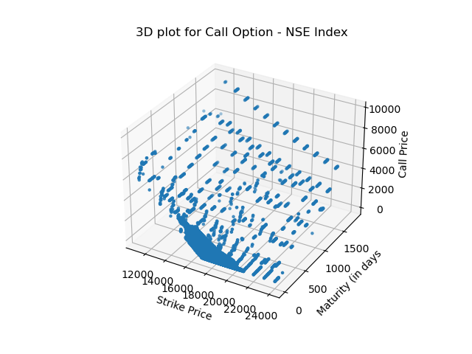

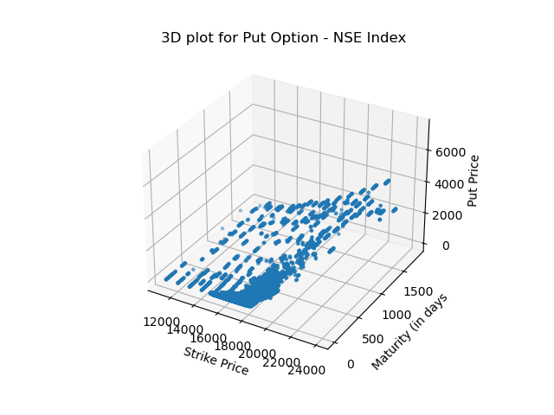

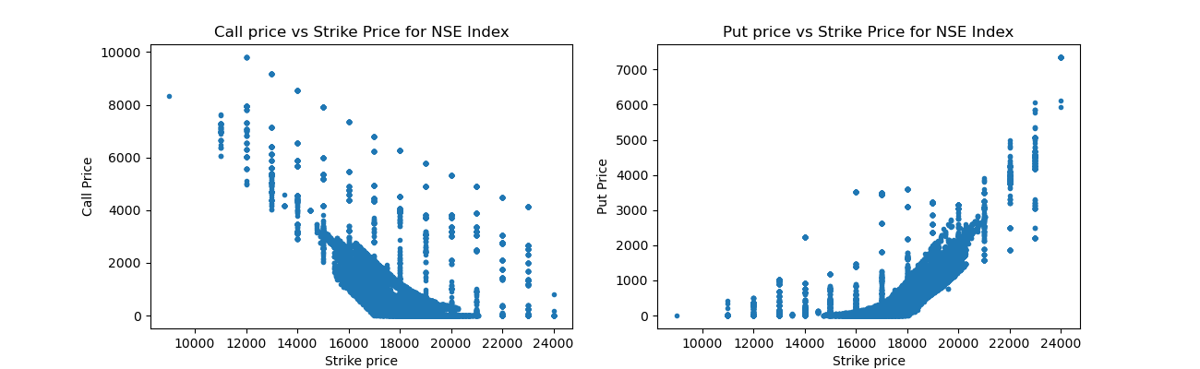

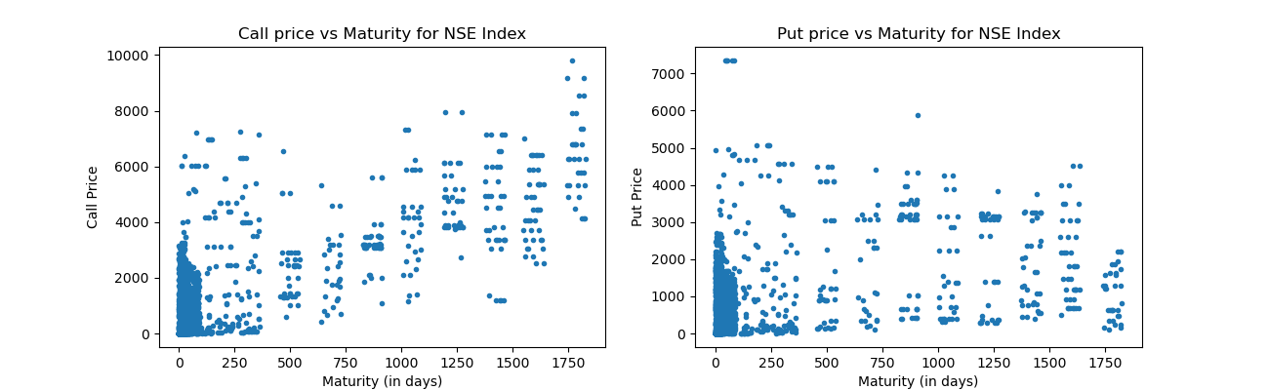

1. Ambuja Cements

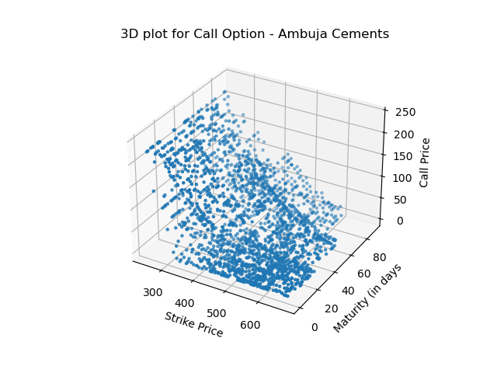

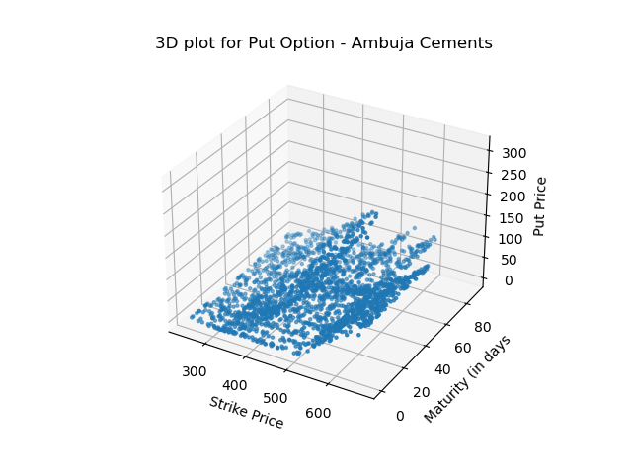

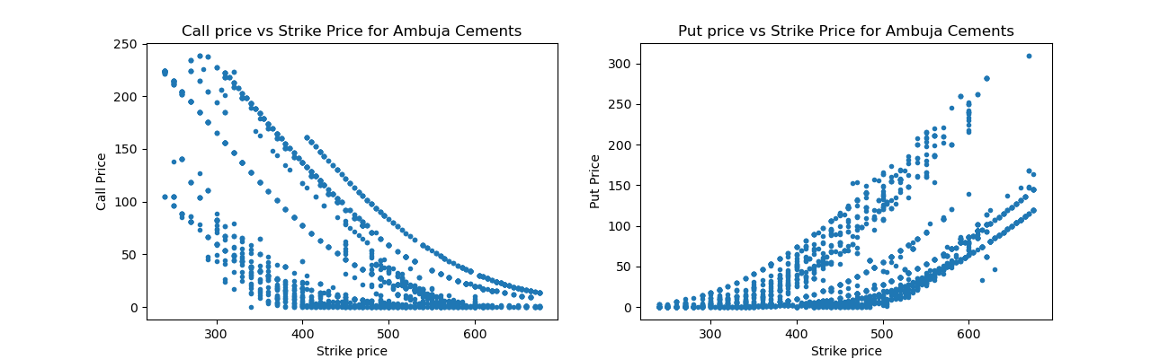

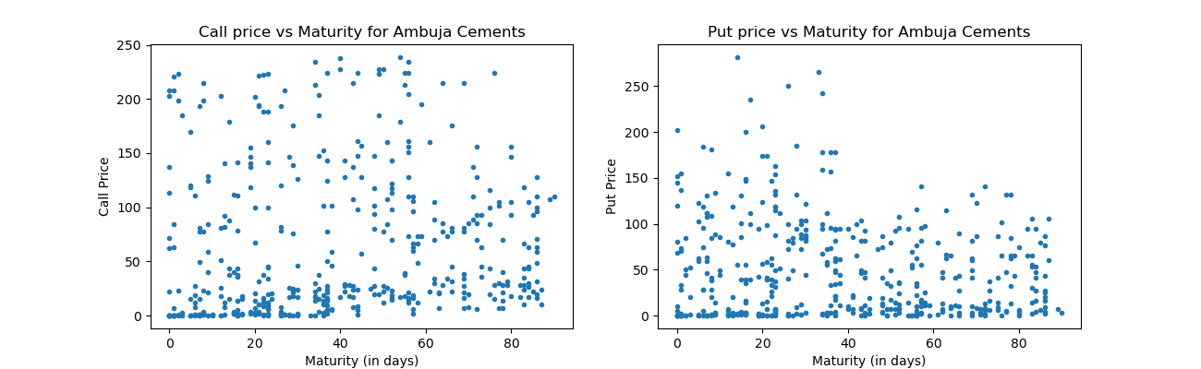

1. Apollo Hospitals

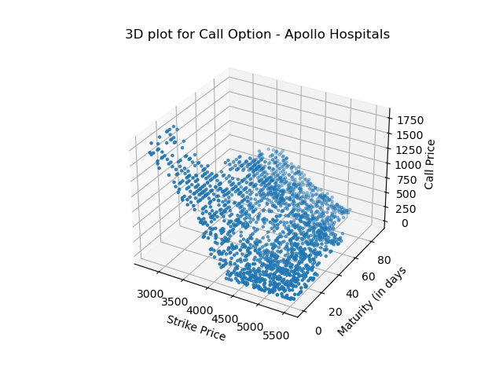

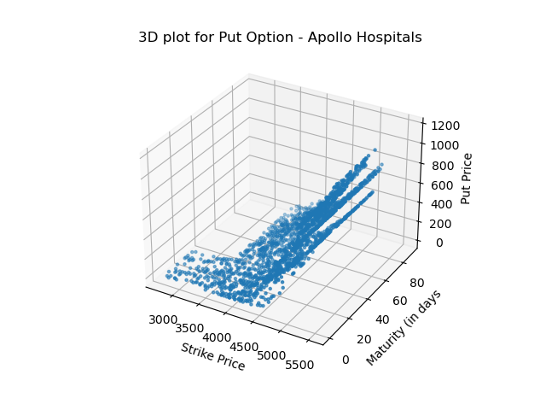

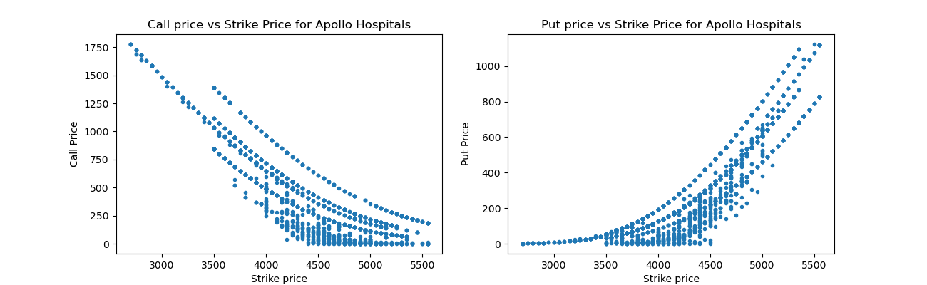

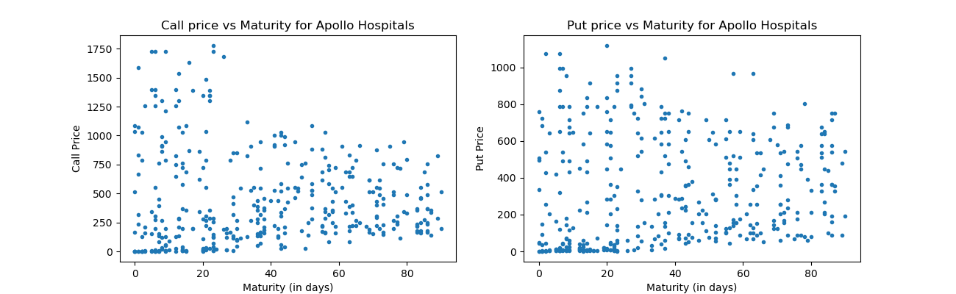

1. InterGlobe Aviation

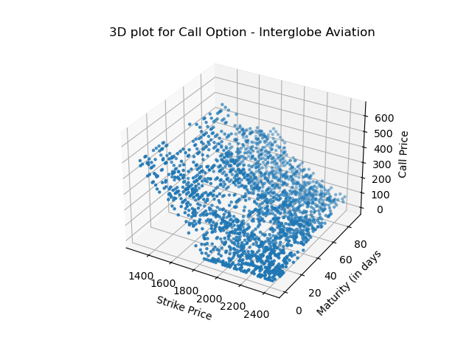

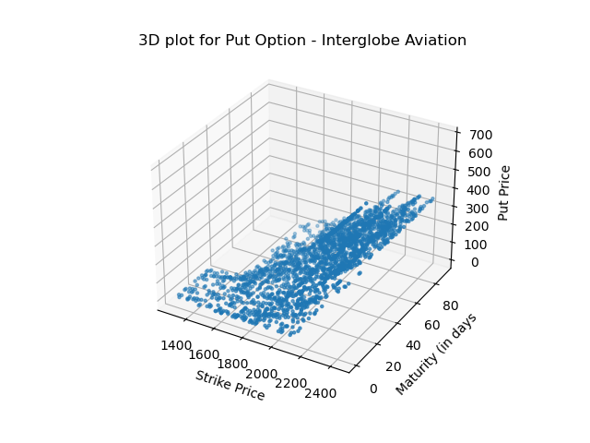

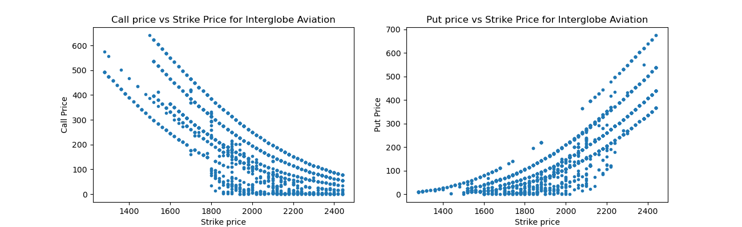

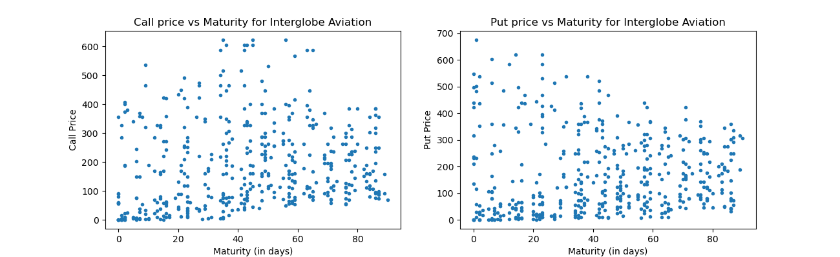

1. Maruti Suzuki

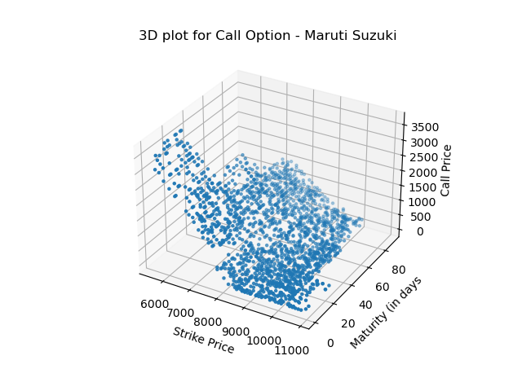

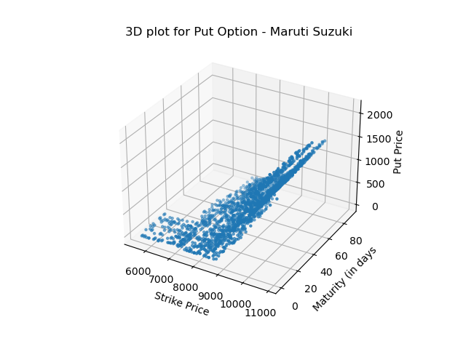

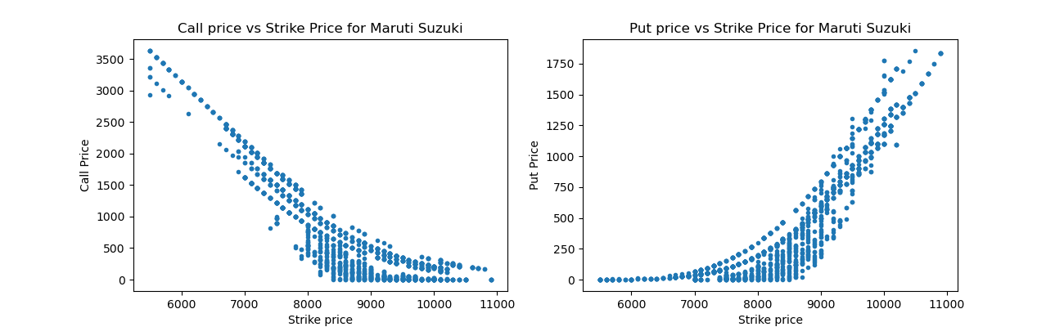

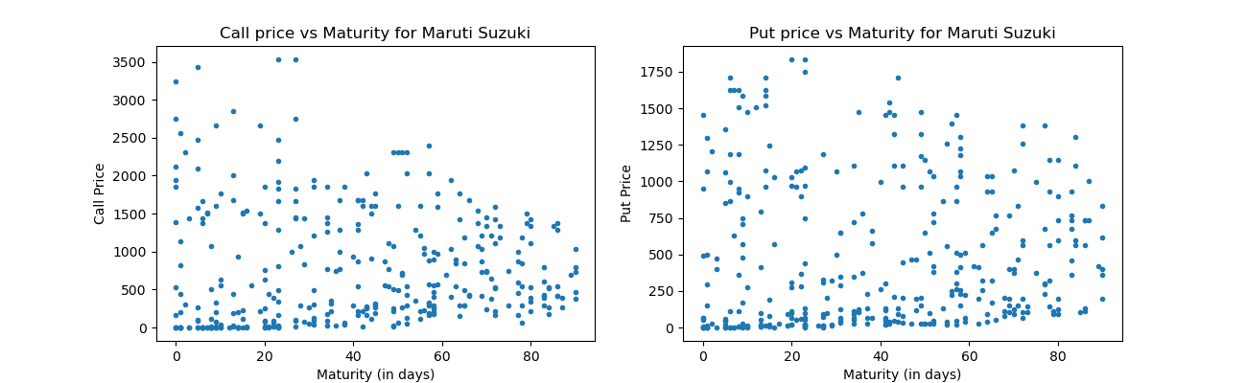

1. TCS

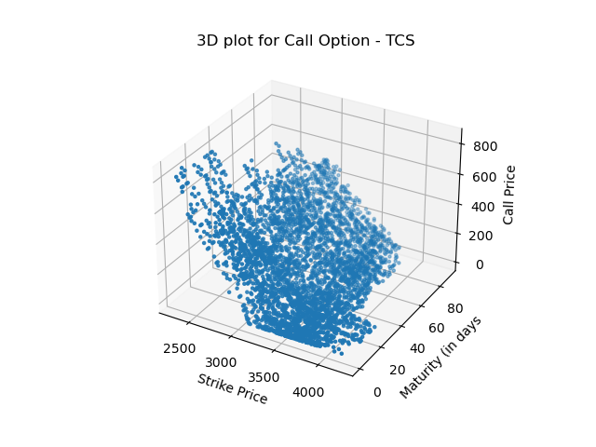

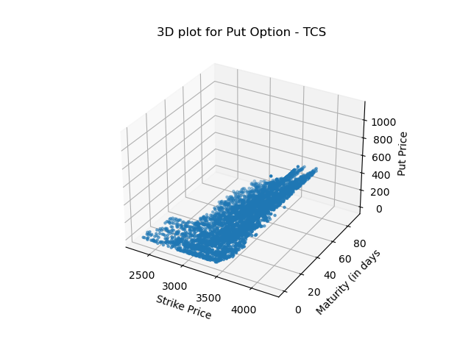

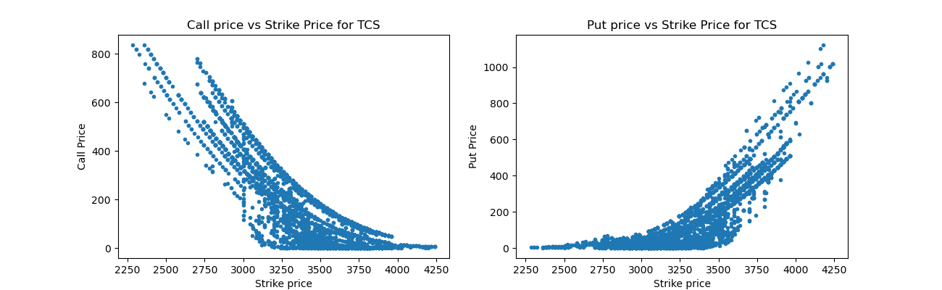

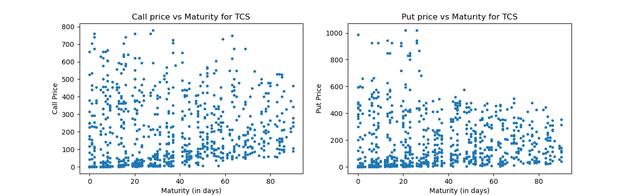

**Observations: -**

1. We can observe that the price of call option decreases and that of put option increases with an increase in strike price.
2. But the plot for call option and put option doesn’t exactly match with our expectations. The general trend is that the price of call option tends to increase while that of put option tends to decrease with an increase in maturity period.

# Ques – 2(b)

Newton-Raphson method is used to find out the implied volatility from the BSM formula.

The price of European Call Option given by BSM framework obtained after solving Black-

Scholes-Merton PDE is: -

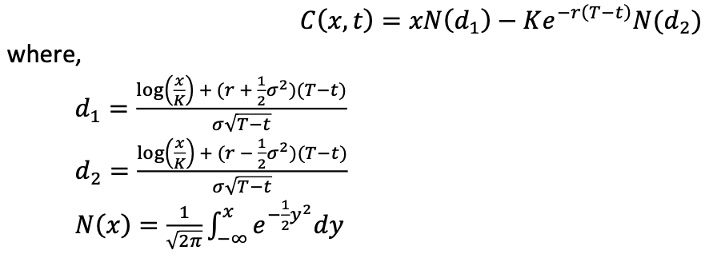

1. Nifty50

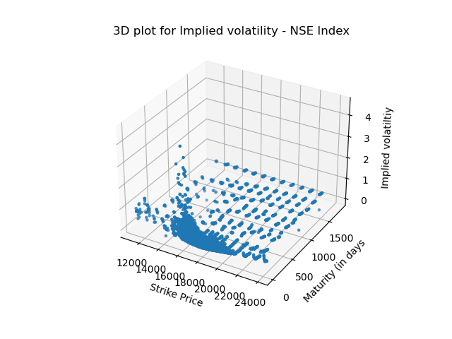

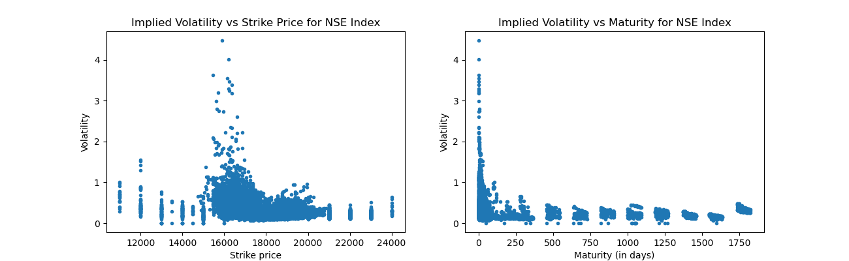

1. Ambuja Cements

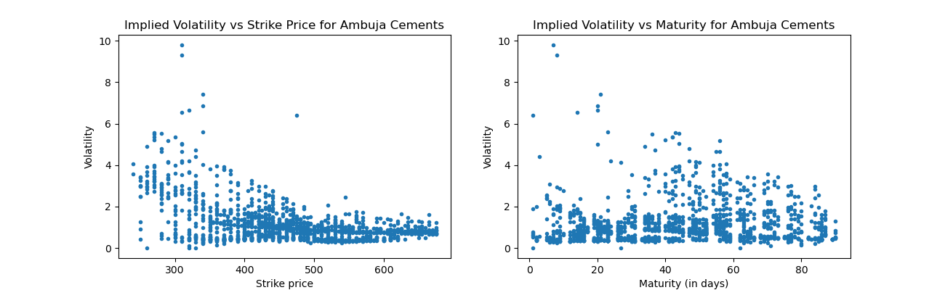

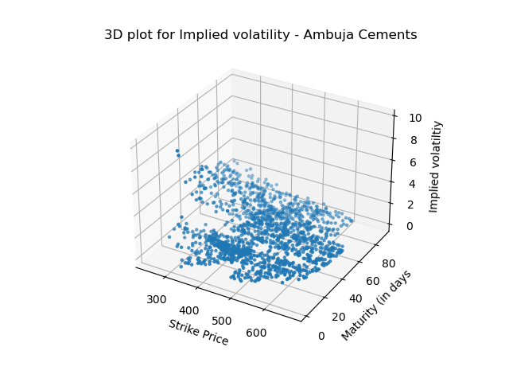

1. Apollo Hospitals

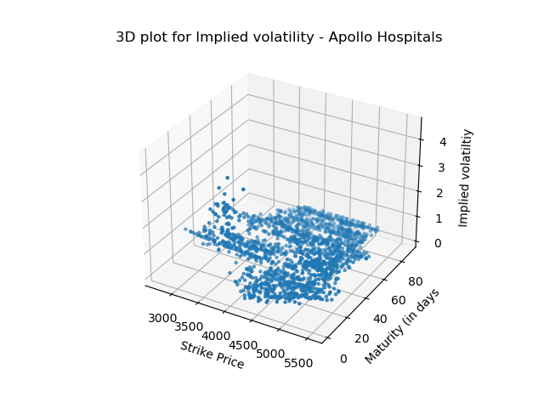

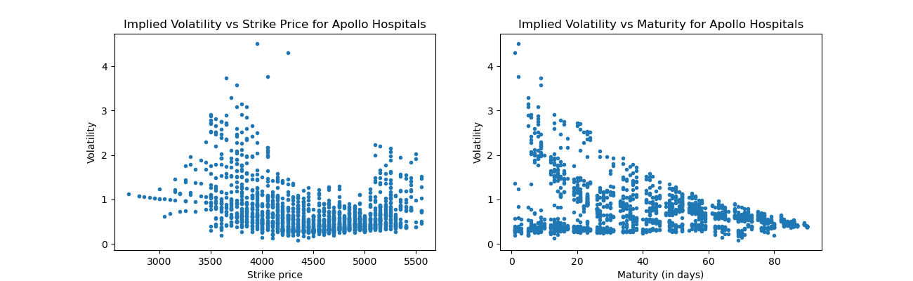

1. InterGlobe Aviation

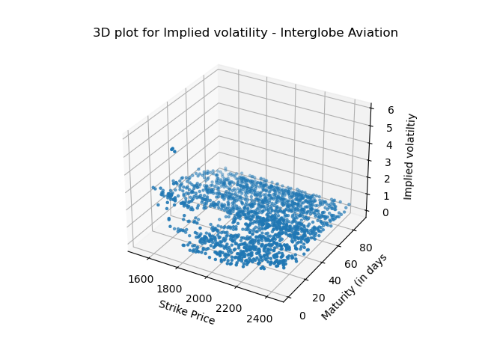

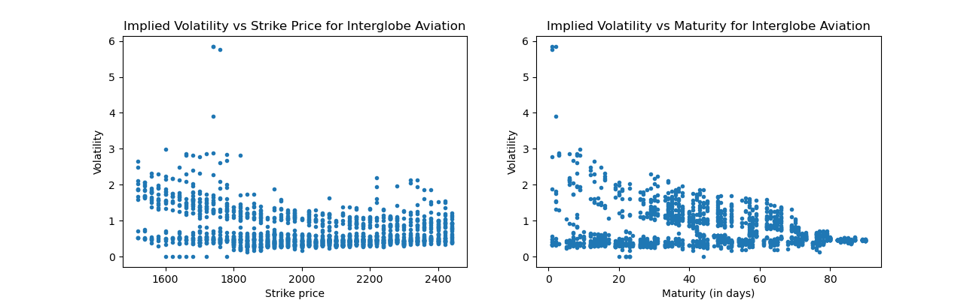

1. Maruti Suzuki

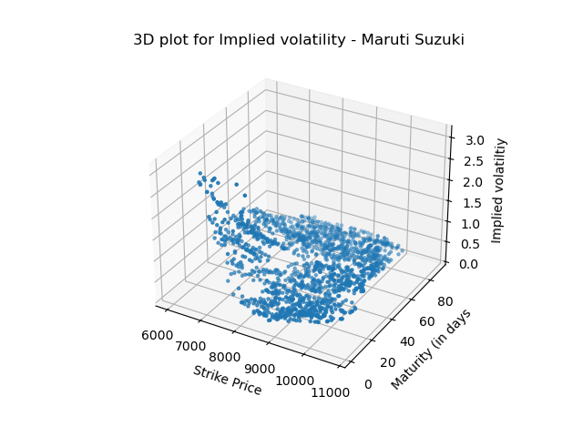

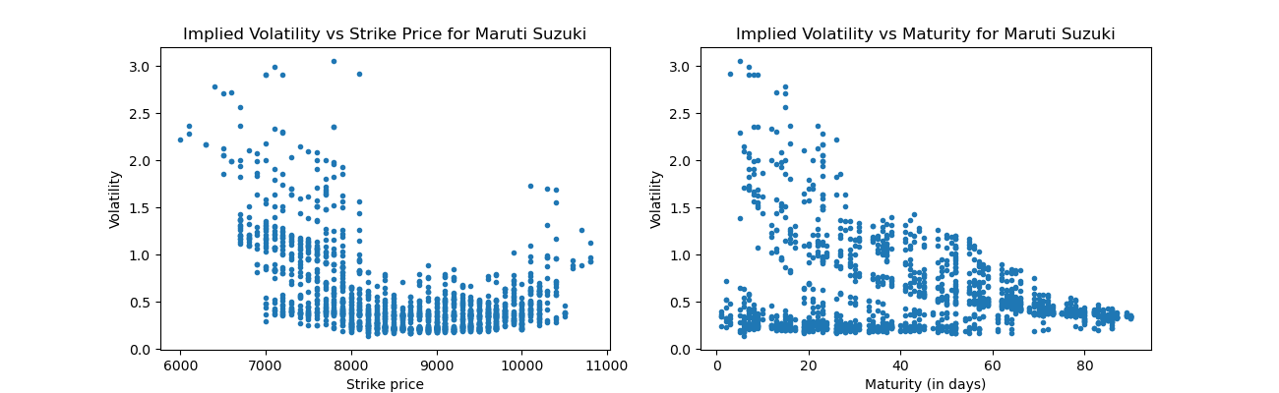

1. TCS

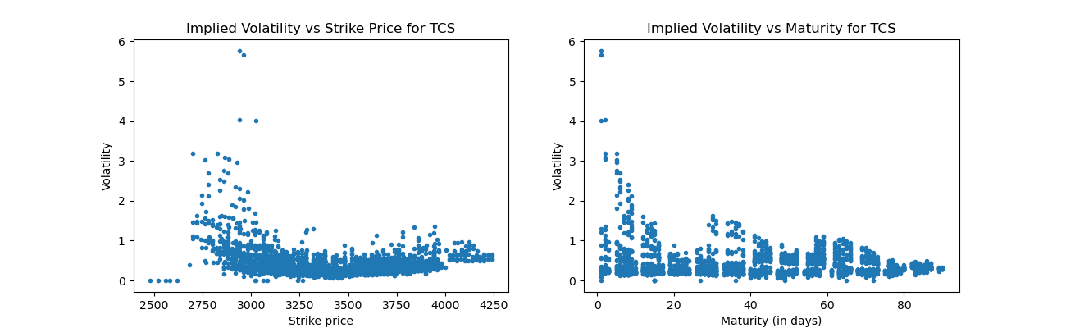

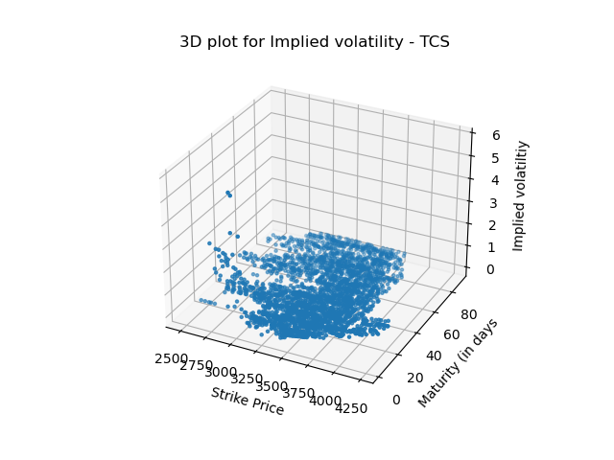

**Observations: -**

1. Theoretically, the implied volatility is generally a convex function of strike price, and the curve so formed is known as the **Volatility Smile**. But this feature is not prominently observed in some of the plotted curves. In some curves, we can observe bit of a smile like shape.
2. The volatility generally tends to decrease for larger maturity values, but for some of the above plots this nature is not very much observed.

# Ques – 2(c)

1. Nifty50

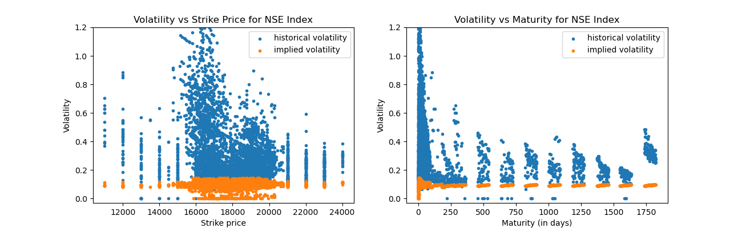

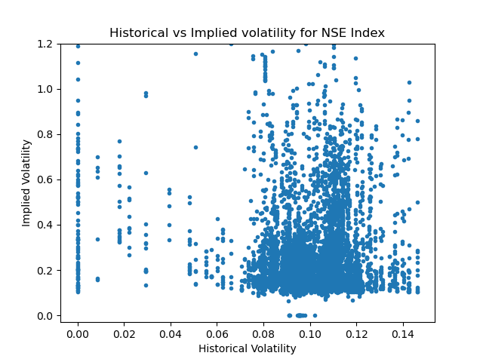

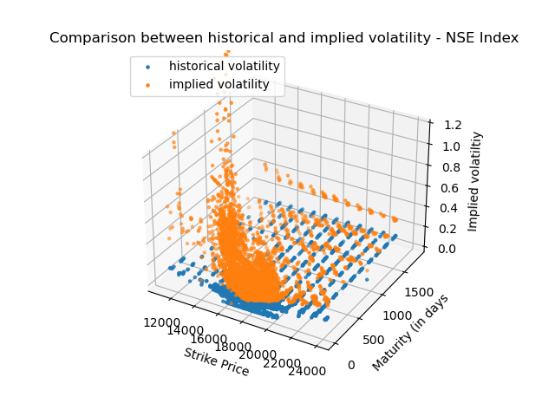

1. Ambuja Cements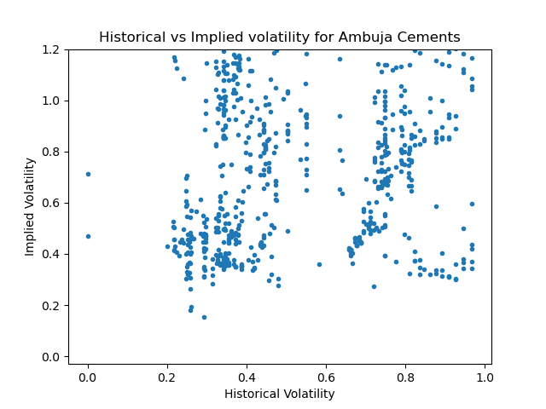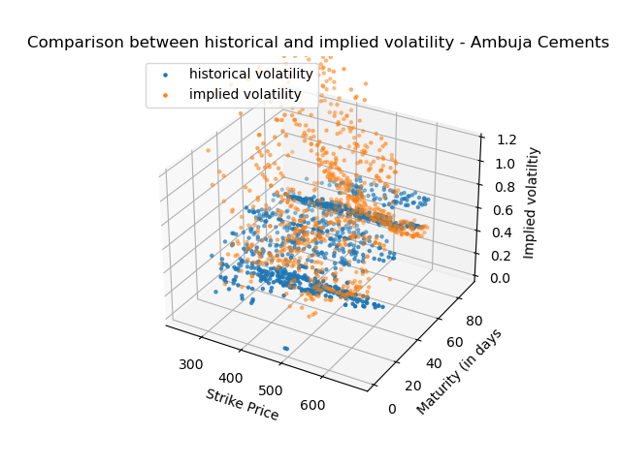

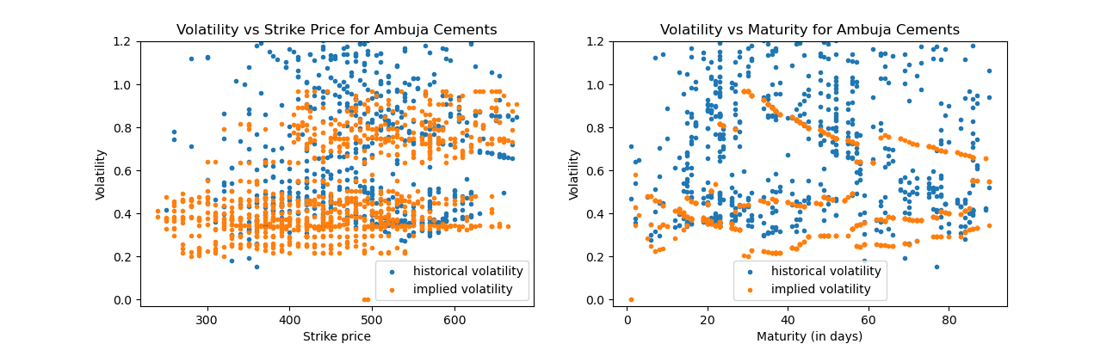

1. Apollo Hospitals

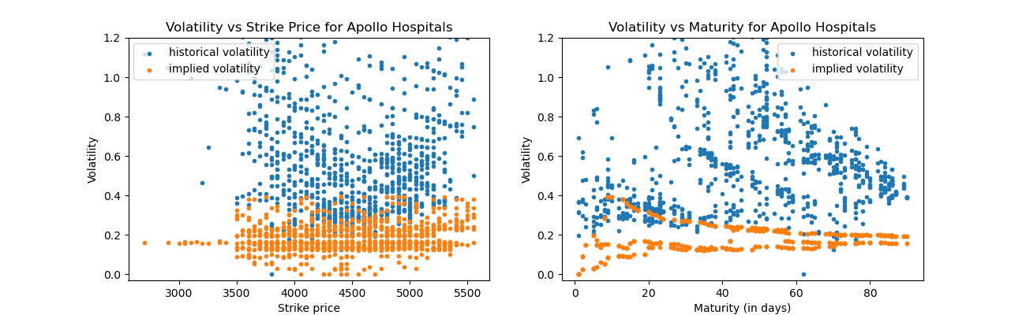

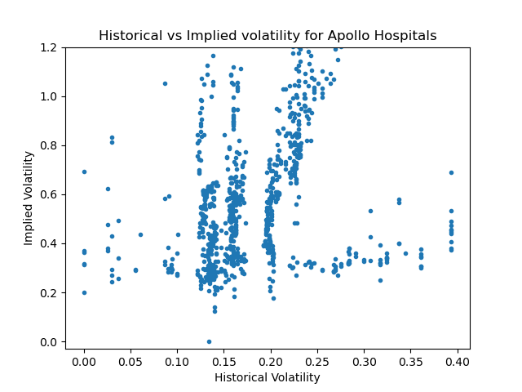

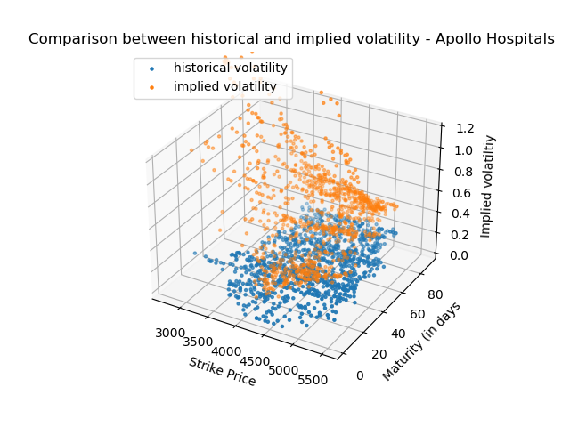

1. InterGlobe Aviation

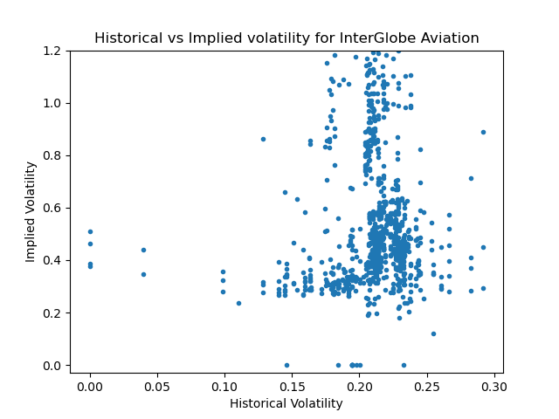

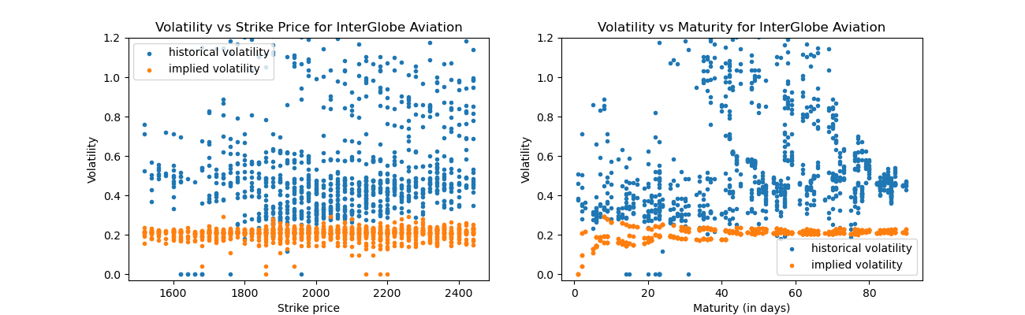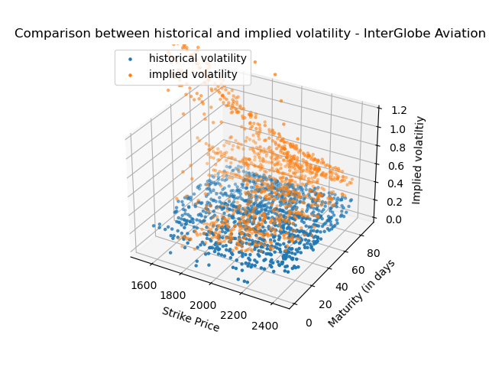

1. Maruti Suzuki

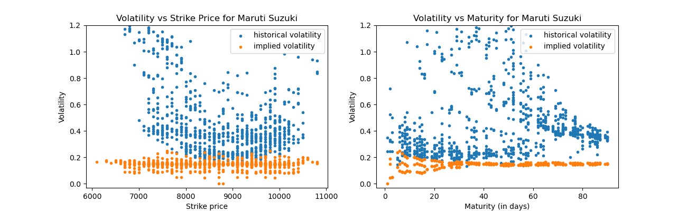

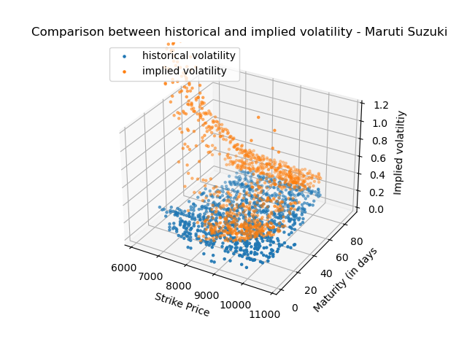

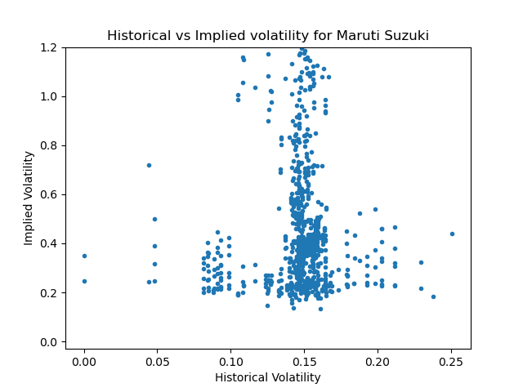

1. TCS

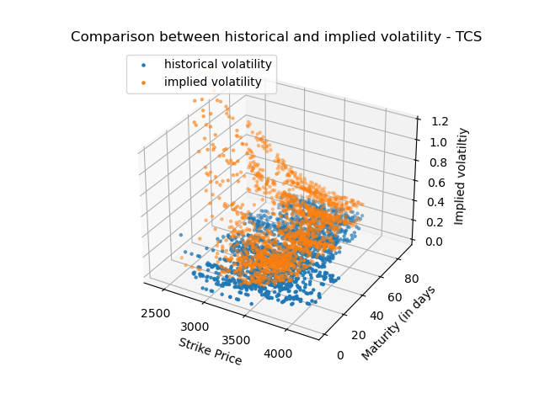

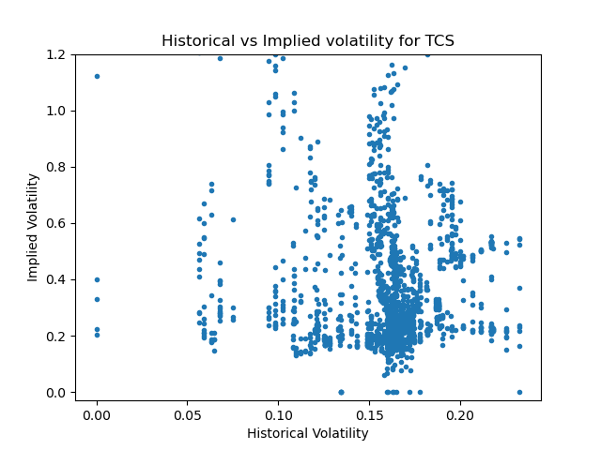

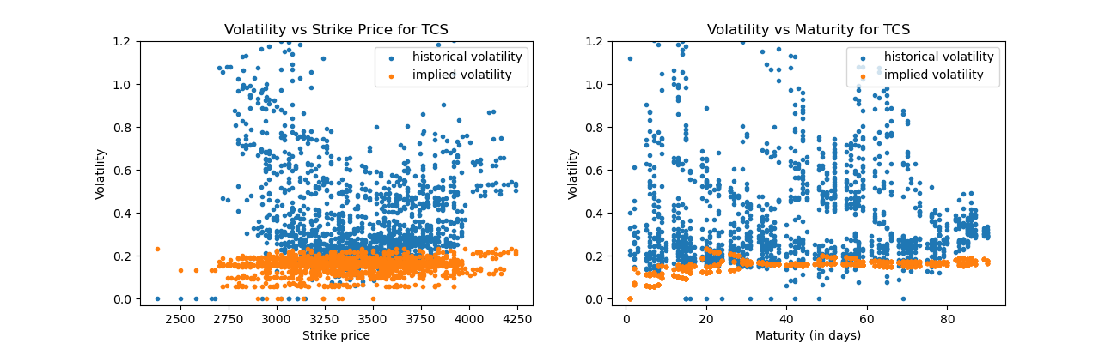

**Tabular Data** (for few points)**: -**

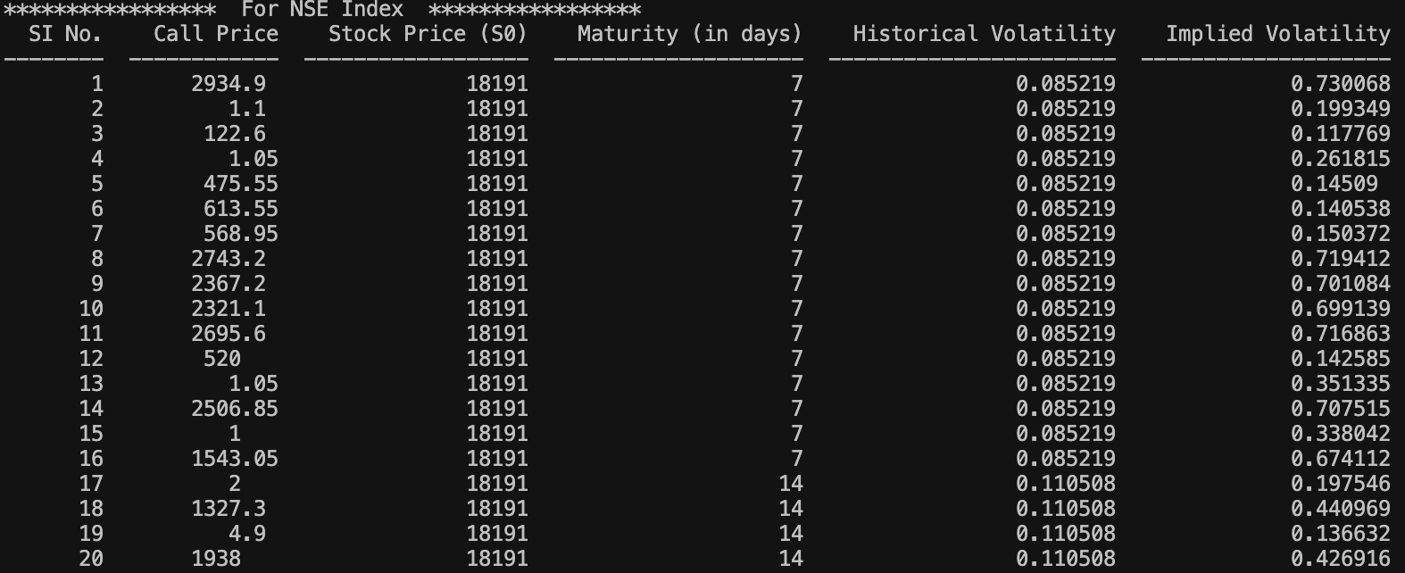

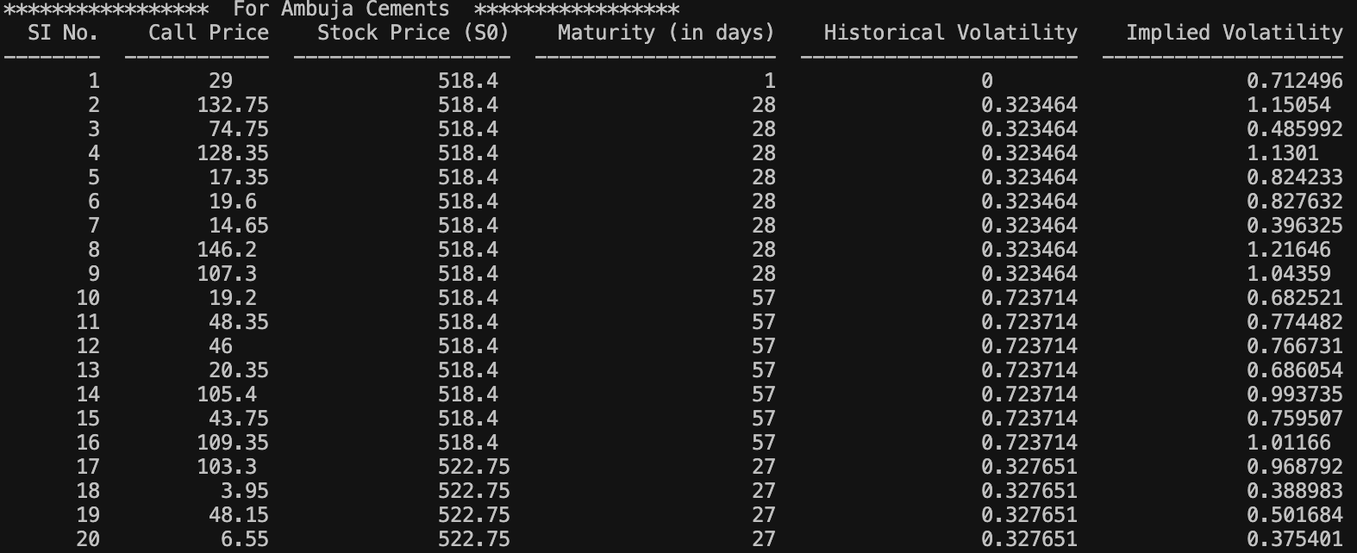

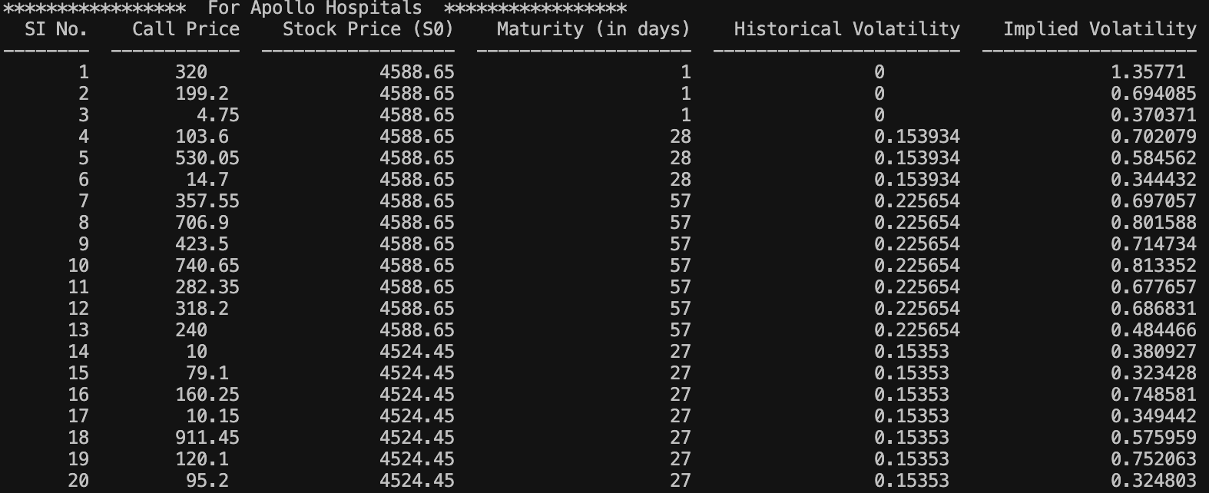

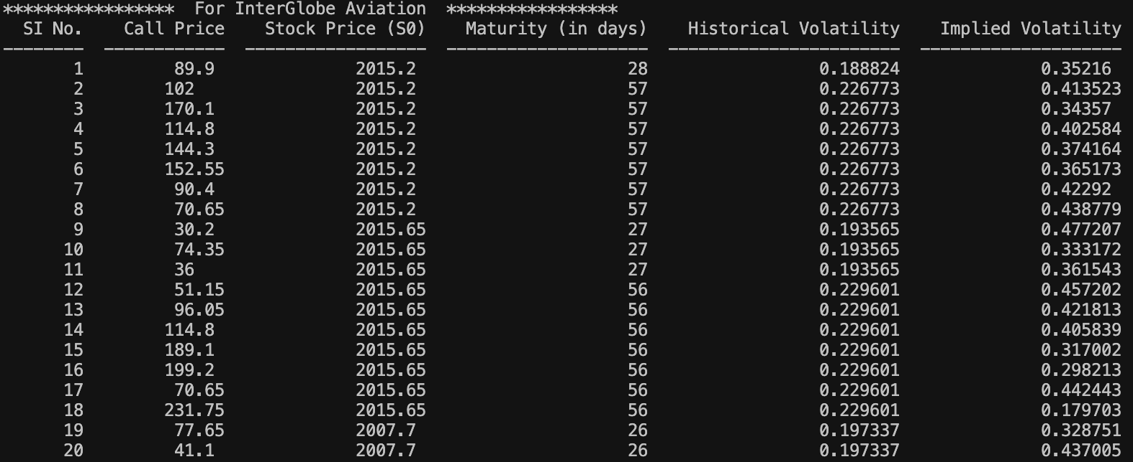

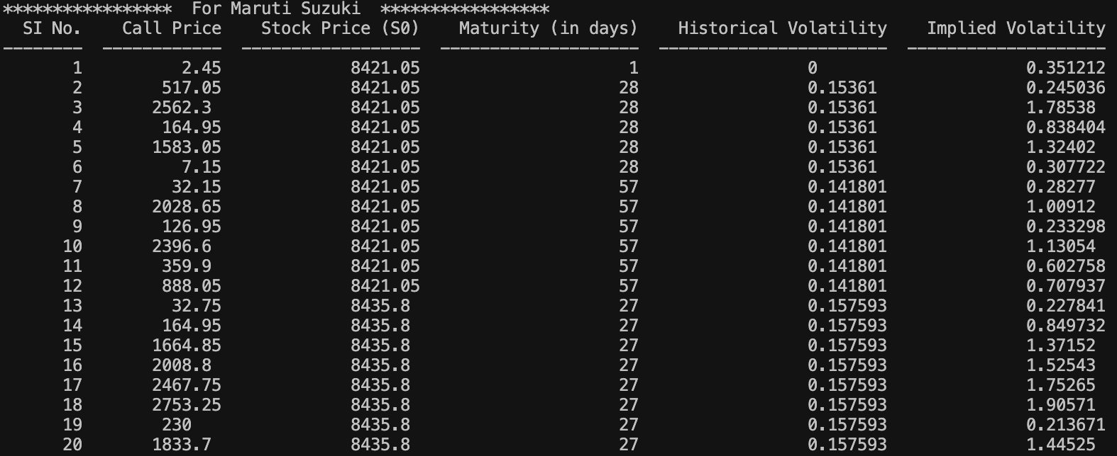

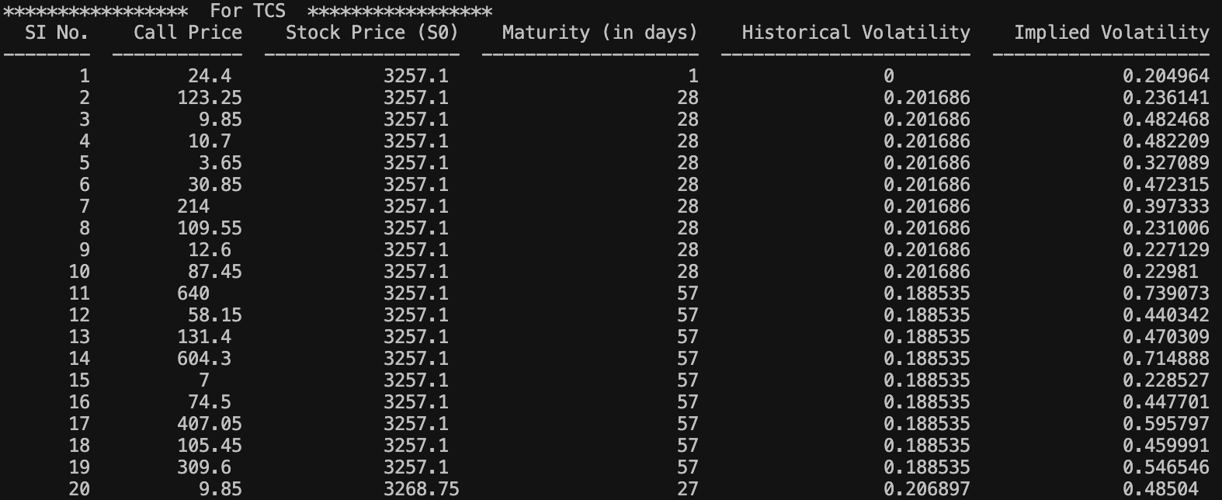

**Observations: -**

1. Historical volatility is an estimate of the volatility over the past period of time, while the implied volatility is the estimation of the volatility for the upcoming months.
2. For data of some of the stocks, implied volatility is generally higher while for other stocks, historical volatility is generally higher than the implied volatility. The significant difference between these 2 values arises due to a number of factors present in real market.
3. The plot for historical vs implied volatility very well captures this relation. Other plots show the dependence of different types of volatility with varying strike price and maturity.